|  |  |  |  |
| --- | --- | --- | --- |
| Version | Date | Comments | Author |
| 1.0 | 14th October 2010 | Created | Bob Bradley |
|  |  |  |  |
|  |  |  |  |
|  |  |  |  |
|  |  |  |  |
|  |  |  |  |
|  |  |  |  |
|  |  |  |  |

**Business Banking - FIM Operations Guide - Solution Migration Procedure**

1. Overview 3

2. Procedure 4

2.1 Generate Audit Drop File for FIM Export MA 4

2.2 Generate Audit Drop File XML 6

2.3 Transform Audit Drop File to HTML 7

# Overview

The following is the process that has been developed by myself for use by UNIFY Consultants in previewing/analysing the pending exports for any given FIM Sync Service MA in MS Excel. The process transforms an XML “audit drop file” generated by a FIM export run profile executed with this logging option selected, converting and saving it to HTML format. The html file can then be either opened directly in MS Excel …

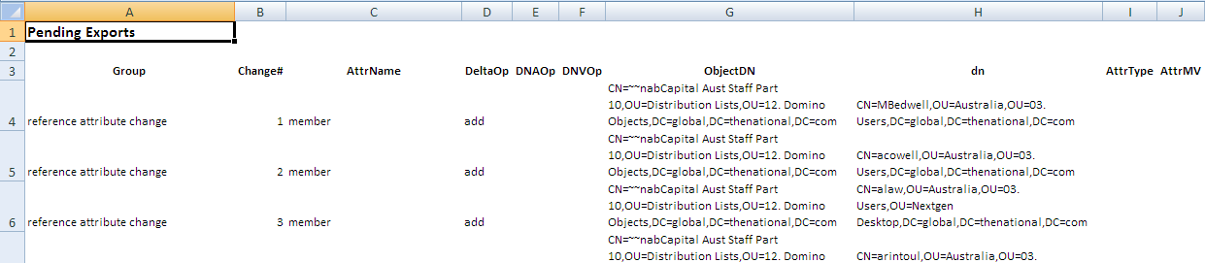

... or opened in a browser and cut-and-pasted into Excel …

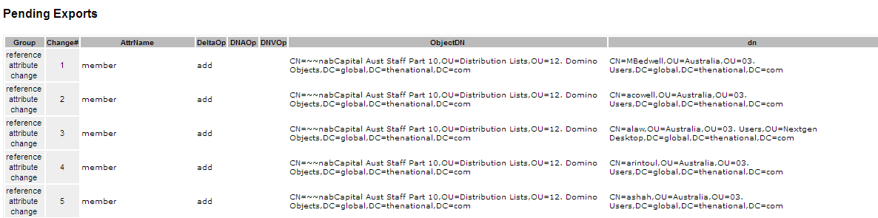

While the utility was written specifically to transform the FIM MA audit drop file, it is totally generic and will work with any xml/xsl file combination.

# Procedure

## Generate Audit Drop File for FIM Export MA

This step can be skipped if the necessary run profile has been previously created.

1. Log onto the FIM PRODUCTION server (MELWASFIM02) as a FIM administrator
2. Open the Synchronization Service console from Start Menu\Programs\Microsoft Forefront Identity Manager
3. Click on the Management Agents tab
4. Ensure no run profile operations are executing (i.e. no scheduled jobs are running, and the Event Broker service – if installed and operational – is shut down).
5. Select the Management Agent you want to configure (e.g. WB AD MA) and from the Action menu select Configure Run Profiles …
6. Click on New Profile … and enter the name of your new run profile:  
   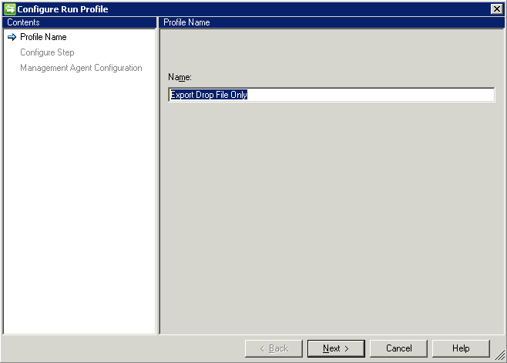
7. Click Next, select type Export, and click on Set Log File Options…  
   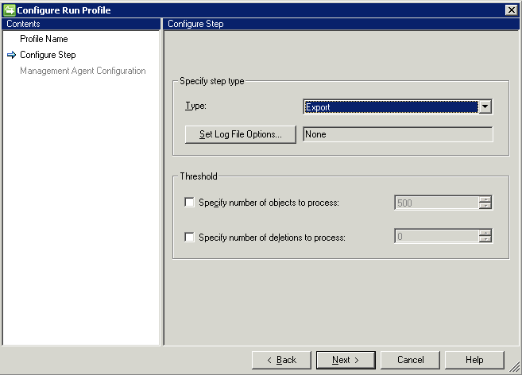
8. Select the Create a log file and stop the run … option, and type the name of the XML file to be generated … this will be created in the corresponding MADATA file for this MA, e.g. C:\Program Files\Microsoft Forefront Identity Manager\2010\Synchronization Service\MaData\WB AD MA\*  
   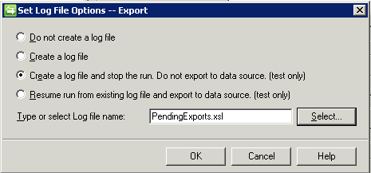
9. Click OK then Next  
   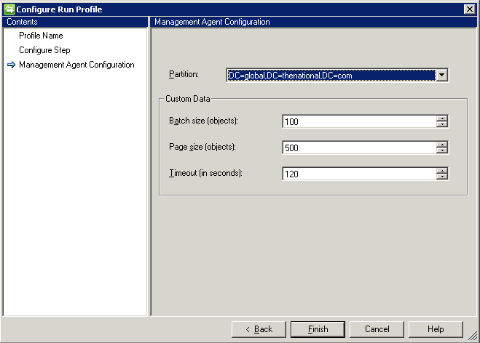
10. Click Finish, then OK to save the new run profile

*Note: The “XML” output will only be generated when the run profile is executed.*

## Generate Audit Drop File XML

1. Log onto the FIM PRODUCTION server (MELWASFIM02) as a FIM administrator
2. Open the Synchronization Service console from Start Menu\Programs\Microsoft Forefront Identity Manager
3. Click on the Management Agents tab
4. Ensure no run profile operations are executing (i.e. no scheduled jobs are running, and the Event Broker service – if installed and operational – is shut down).
5. Select the Management Agent you want to configure (e.g. WB AD MA) and from the Action menu select Run  
   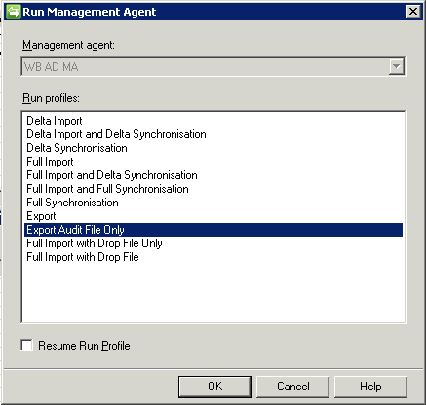
6. Select the EXPORT run profile which will generate the XML audit dump file, and click OK
7. When the run profile has finished executing, open Windows Explorer to the MADATA folder corresponding to this MA … e.g. C:\Program Files\Microsoft Forefront Identity Manager\2010\Synchronization Service\MaData\WB AD MA\
8. Check that the expected XML file has been generated.

## Transform Audit Drop File to HTML

1. Log onto the FIM PRODUCTION server (MELWASFIM02) as a FIM administrator
2. Open Windows Explorer to the C:\FIM Migration Files\TransformXML folder and run TransformXML.exe  
   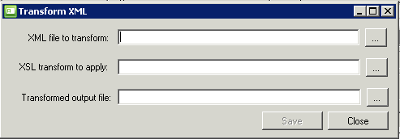
3. Use the first file selector button to select the XML file generated in the previous step, e.g.  
   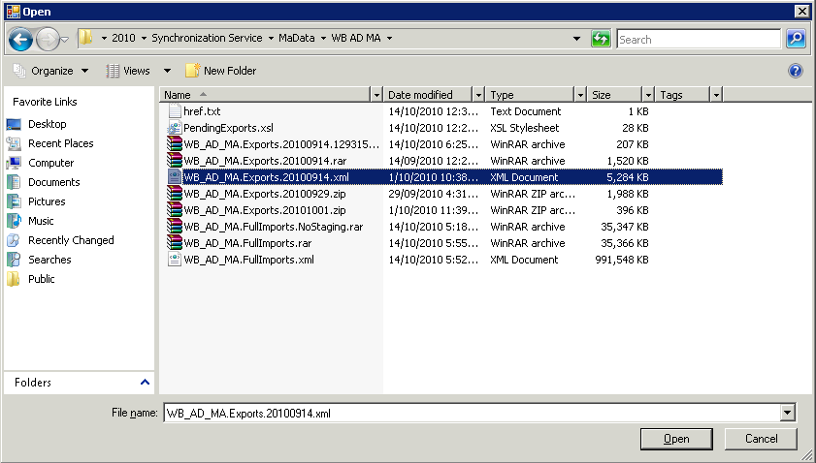
4. Click Open, noting that the Transformed output file has been defaulted based on the selected XML file  
   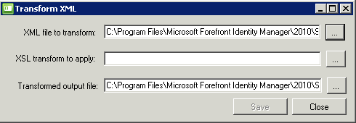
5. Use the second file selector button to select the XSL file to be used to transform the selected XML – noting that by default this is PendingExports.xsl  
   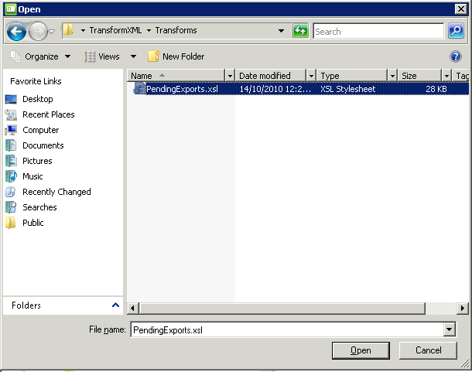
6. Click Open  
   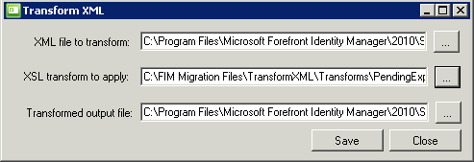
7. (optional) Use the third file selector button to select an alternative transformed output (generally HTML) file from the default
8. Click Save
9. Locate the generated output file and transfer to a file location accessible to either MS Excel or a browser.